**Exp. 22 SQL Storage Service**

**Aim:**

To create a SQL storage service and perform a basic query using any Public Cloud Service Provider (Azure/GCP/AWS) to demonstrate Database as a Service (DaaS)

**Procedure:**

* Sign in to Azure Portal
* Create a resource group
* Create a VM
* Open the VM by entering username and password
* Install MySQL (Server only) inside the VM
* Now the database is ready.

**Output:**

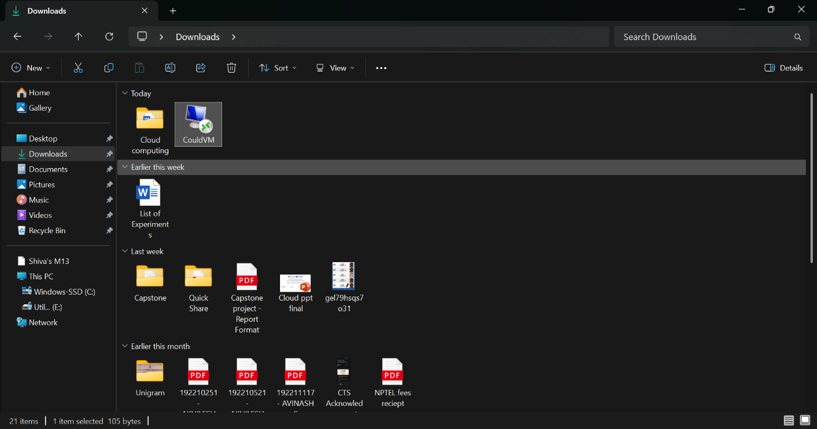

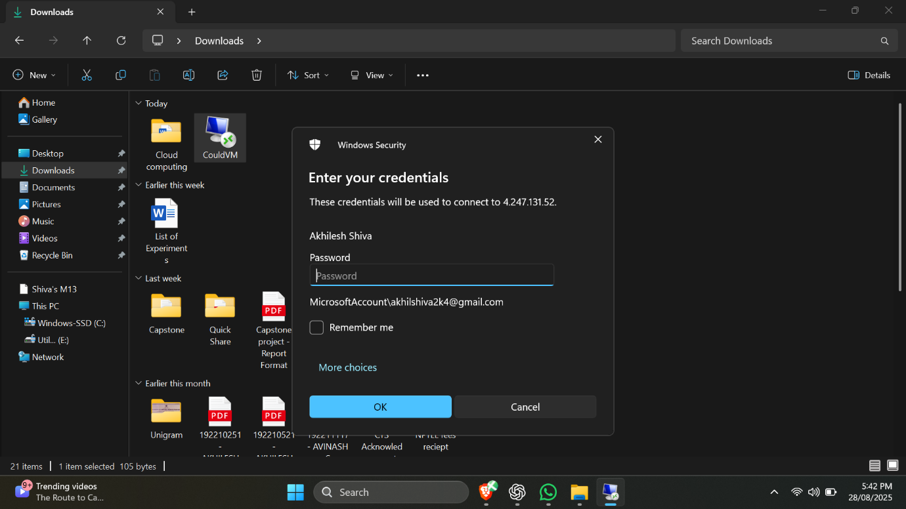

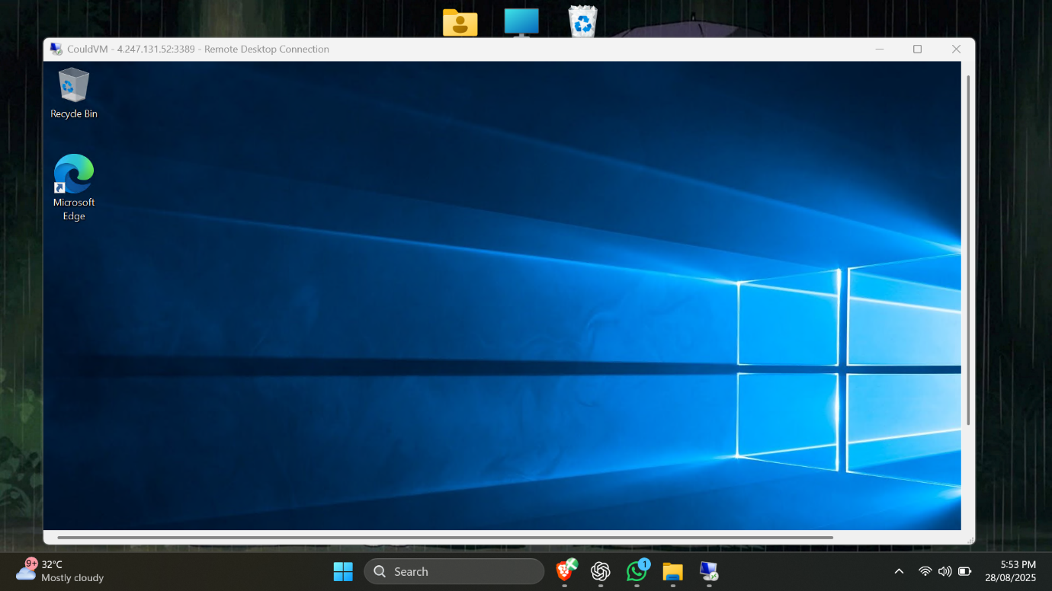

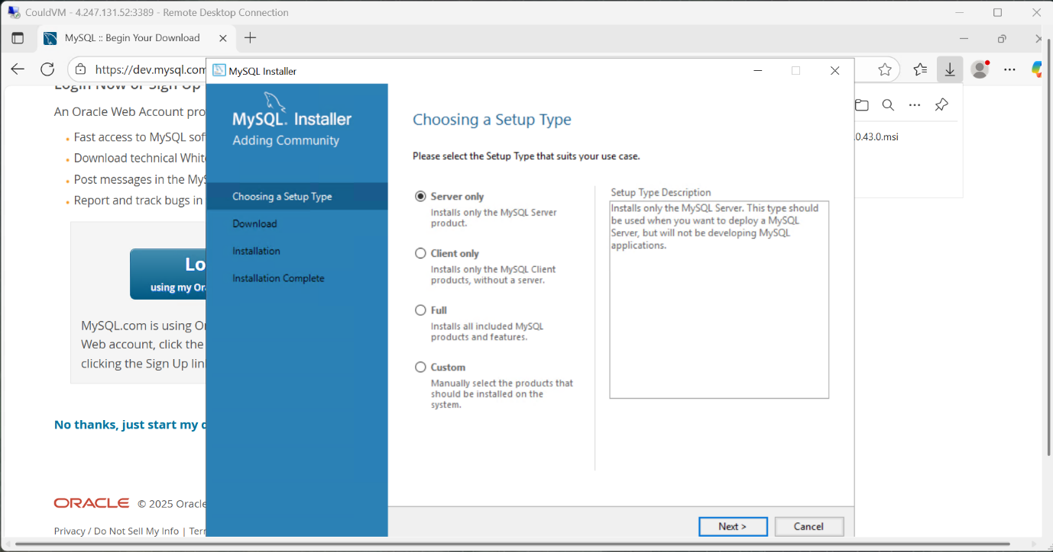

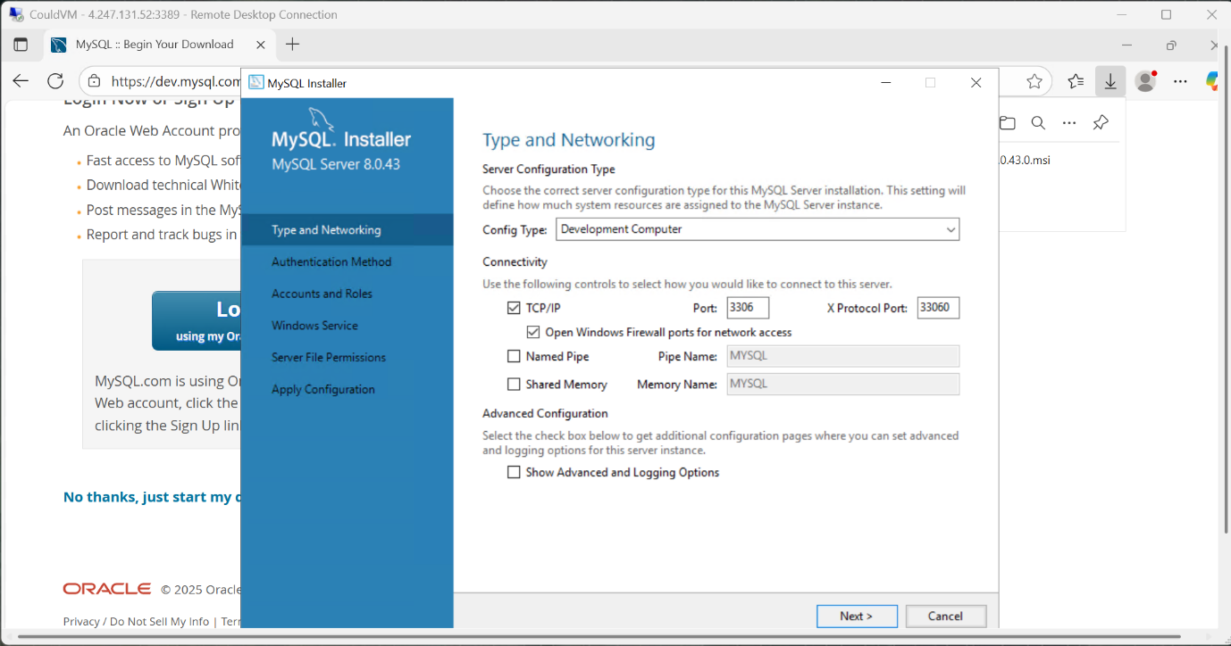

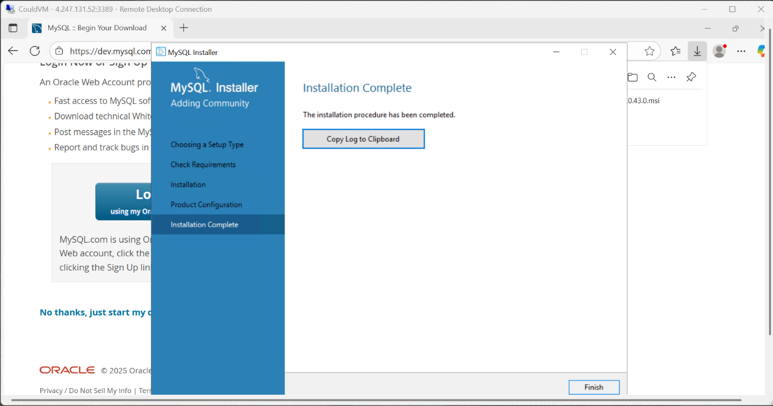

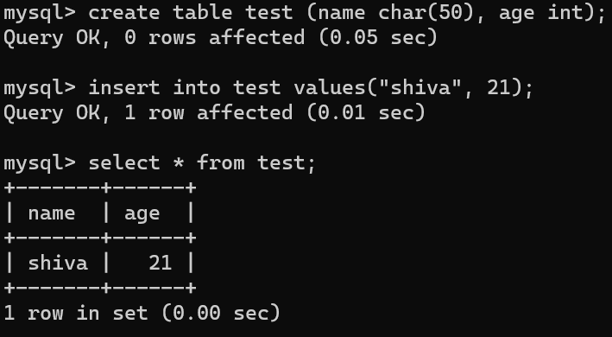

**Result:**

Thus, a simple query was executed in MySQL in the VM